AgriSOS: Early Farmer Distress Prediction and Risk Advisory System
Twinkle Ghodki¹
School of Computer Science and Engineering, Vellore Institute of Technology, Chennai, India¹

Abstract – AgriSOS is a smart, data-driven agricultural advisory platform. It keeps track of farmer's distress and provide various options to farmers before they lose their crops or economic loss. It uses machine learning methods to give early alerts of possible agricultural risks and therefore can be used for pre-emptive planning by farmers and other agricultural stakeholders. Through the integration of various data sources such as up-to-date weather data, market price trends, soil data, and farmer inputs, AgriSOS is able to produce a detailed Distress Risk Score that ranges between 0 and 100 along with risk level categories (Low Medium High). Random Forest Classifier which was trained on a domain-relevant dataset is the main engine that produces predictions.
Besides forecasting, this platform aids explainability by pinpointing the main factors impacting the risk level which, in turn, will foster user confidence and open communication. An interactive web-based dashboard that is created using the Streamlit package is used to present the visualization in a form of risk dials, trend charts, and a district level analysis. Besides, to increase the accessibility and ease of use,AgriSOS offers customized recommended actions in various local languages so that even a farmer who does not know English can easily understand and implement the instructions.
Through the integration of real-time data, predictive analytics, and user-focused design, AgriSOS is able to solve a major issue in the field of agricultural technologies changing the method of dealing with problems after they happen to managing risks even before they occur. This idea could really work well in enhancing the strength of farming, lessening farmers' risk, and promoting green ways of farming with giving help at the right time based on good information.
Keywords – Advisory Platform, Economic Loss, Machine Learning Methods, Early Alerts, Distress Risk Score, Random Forest Classifier, Multilingual Customized Recommendations.

I. INTRODUCTION
Agriculture gives food to India's economy and keeps millions of farmers working. But what if bad weather, rising input costs, or soil loss hit at the same time? The system reacts only after damage shows up. Farmers don't get warning signs before the crop fails. Probably, that's why so many suffer financially without a chance to stop it early.
Weather alerts, crop advice, and market updates have come online. Still, most tools work alone, no big picture view of risk. A lot of these platforms don't explain things clearly. That means rural farmers can't act on the data. It tends to stay in technical language they can't understand. There's no simple way to translate warnings into steps they can follow.
AgriSOS has been put forward as a remedy for these shortcomings by offering a new agricultural risk management system that is integrated and predictive. This system uses several data sources, such as weather data obtained in real-time,market trends,soil conditions, and farmer inputs, to analyze the chances of distress even before it happens. Basically, with the help of machine learning methods, AgrisOS is able to produce a risk score that can be measured and at the same time it also classifies the level of distress, which helps users to not only understand the seriousness but also the factors that caused it.
The framework has been conceived in a way that it can be used and reached easily by the target audience. It shows the information in a very understandable way, and supports creating recommendations at the individual level in many regional dialects. Farmers will be able to grasp the messages and are likely to even be able to carry out the directives upon the information given to them comfortably.AgriSOS, through this strategy, intends to uplift farmers by providing them timely knowledge,foster planning based on early warning, and help in the creation of aagriculture ecosystem that is resilient and sustainable.

II. BACKGROUND STUDY
Agriculture in India depends so much on natural factors and market fluctuations that it is considered very uncertain and risk-prone by nature. Many farmers, especially those with small or marginal farms, depend mainly on the monsoon rains, prices remaining in a certain range, and the availability of inputs at reasonable prices to make a living. But, weather conditions getting worse, sudden changes in temperature, increased number of pests, and price markets going up and down all the time make these farmers' lives very difficult and at times, even lead to agricultural distress. Most times, such problems come into light only when they cause extreme damage and at that point, farmers hardly have any means to overcome the situation. Over the last ten years, technology has made it possible to create multiple digital platforms related to farming, which give help to the farmers in various ways.
Typically, these platforms offer services such as weather forecasts, crop advisory, soil testing, and updates on the prices in the market. Even though these kinds of systems have made it easier for the farmers to get information, on the whole, they are functioning as separate and independent tools most of the time. The majority of such platforms target only one apsect of farming, for example, the weather or pricing, without considering the various aspects together in order to do a risk assessment. As a consequence, farmers get disconnected pieces of information instead of a thorough knowledge of their situation.
Existing systems also suffer from not having features that can forecast events. While many tools offer the historicl or instantaneous data, they rarely predict a farmer getting into trouble situation ahead of time. Besides this, the deliverables are mostly complicated and hard to decode and this leads to a farmer being clueless about the grounds in support of an advice given. Furthermore, the limited use of languages mainly English in most platforms acts as a barrier by making it very difficult for rural people to benefit from these services.
These inadequacies emphasize that the agricultural support systems should be able to use a starting point that is more comprehensive and predictive. Farmers would be greatly improved in their decision-making if they had a solution that brought together/connected different information sources, measured exposure to hazard, and gave clear and definite hints to step by step their actions. Such inspires the idea of AgriSOS that is the one to come behind the scenes to the realization phase by means of an early warning system that is not only smart but also very easy and comfortable to work with.

IV. PROPOSED SYSTEM
The proposed system AgriSOS is conceived as a smart and consolidated platform that forecasts possible agricultural crisis and delivers prompt, practical guidance to farmers. Instead of depending on isolated data sources say weather advisory tools, AgriSOS integrates several important factors -e.g.real-time weather,market price trends,soil characteristic, farmer's inputs - into one predictive model. Such integration allows the risk to be understood from a more global perspective which makes the system both user-friendly and highly effective.
AgriSOS's main value proposition is offering forecasted output instead of only reporting information. The main component of the system is a machine learning model based on the Random Forest algorithm, which is capable of simultaneously handling several features in order to determine the probability of distress. The system does not suggest typical advisories but instead it produces a quantified Distress Risk Score on a scale from 0 to 100 together with clear classification levels (Low Medium High). This way of expressing numerically makes it straightforward for the user to understand the seriousness of the condition and to make a decision about the best course of action.
One more thing that really sets AgriSOS apart from the other ones out there is its focus on explainability and its user-centered design. Besides just forecasting risk, it identifies the primary factors that have led to the risk assessment, like a drop in rainfall or a lowering of market prices, and makes it clear to the users why they have been assigned a certain risk level. It also gives localized advice in several regional languages, which is very important for making the tool available to the farmers from the different linguistic communities. The process of AgriSOS is that initially the farmer inputs basic information like crop type location soil condition, and development stage via a web portal.
Then the system supplements this information by retrieving up-to-date weather data and simulating market trends. These inputs are guven to the machine learning model that generates the risk classification and the score. The output is displayed on a user-friendly, interactive dashboard with charts, indicators, and summaries, etc. to help the user easily understand the information. In brief, by merging predictive analytics, multi-source data integration, and explanatory outputs into one system, AgriSOS comes up with a completely new idea. It is essentially the reconstitution of disparate agricultural data into a unified, early warning system. It is a key enabler to the farmer's capacity for making well-informed and timely decisions. That is, by extension, an important factor in agricultural resilience and sustainability.

V. SYSTEM ARCHITECTURE
AgriSOS architecture is planned as a structured, multilayer system that allow the smooth transfer data from the point of input to the ultimate decision support. The overall concept implements a left-to-right pipeline made up of layers input, data integration intelligence processing, and output ensuring transparency, modularity, and scalability.

It all starts at the Farmer Input Module where the user many provide a crop type district growth stage, soil moisture and input cost, in order to determine the basic dataset for the later analysis. The system incorporates external data through the Weather Data Engine and Market Price Engine simultaneous to the user input. The Weather Data Engine retrieves current and future weather-related data like precipitation and temperature from Open-Meteo API. On the other hand, Market Price Engine looks up the latest price variations and carries out a simulation of market conduct for a given time period.

The core of the entire system (ML Prediction Engine) is the part that accepts these inputs and employs the Random Forest classifier in order to analyze the different features together. The model examines the combined effects of environmental, economic, and crop factors to decide the severity of distress that is here divided into High, Medium, and Low levels.It is at this point the system brain operates or where the system does predictive analytics.

The next step after the forecast is the Risk Score Calculator that generates a number or score from 0 to 100 by implementing a formula that is weighted. This score quantifies the level of risk and thus facilitates better understanding of the output.

Lastly, the Output Layer sends the processed data to the users via the Streamlit Dashboard, Recommendation Engine, and Alert System. The dashboard is a visual presentation of results: charts, risk indicators, etc. The recommendation system is multilingual and helps users get their tasks done. The alert system is the one that tells users about something in time. Such elements jointly form a comprehensive and easily operable decision support system to assist agricultural risk management in a proactive manner.
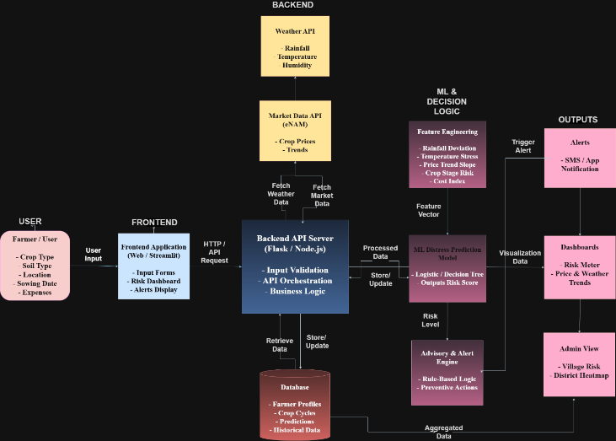

Fig. 1. The above architecture diagram shows the overall flow of the system. At a real implementation, the machine learning model that is used is a Random Forest Classifier instead of Logistic/Decision Tree. The system is implemented using Streamlit without a separate backend server, and market data is simulated rather than fetched from an external API. SMS alerts are delivered using the Twilio API.

VI. PROTOCOL STACK
The AgriSOS system relies on a specially designed layered protocol stack that arranges the movement of data and the delegation of tasks among the various parts of the application. Such a layered style of working not only facilitates the modularity and mutual understanding among the different parts of the system, but also promotes the effective communication of these parts.

At the highest level is the Presentation Layer, which is the user interface built with Streamlit. The functions of this layer include handling all user communications such as receiving data from users through forms and presenting them results like risk scores, charts, and recommendations. Besides, it makes the system remain simple enough for any user and also be accessible on different devices.

Next is the Application Logic Layer, which plays the role of the system's main organizer. This layer understands and acts on user inputs, controls the overal execution, and links different modules including prepaing, making API calls, and forwarding the resulting data to the machine learning unit.

The Intelligence Layer is the heart of the system, Random Forest model doing the predictive analysis. It looks at many features at the same time to judge how serious the distress is and it also helps in making decisions by giving insights based on data.

Then, Data Integration Layer is the one who talks to outside world like weather API, market data processing, and messaging services. It is the one who fetches data, changes formats and also the one who deals with errors to make sure that the interaction with these external systems is very smooth.

Lastly, Infrastructure Layer is responsible for giving the running environment of the whole application. It is on a cloud platform, so it can make sure the system is always on, can grow when needed, and can safely handle configurations and dependencies. All these layers combined make AgriSOS work as one integrated and highly efficient predictive system.

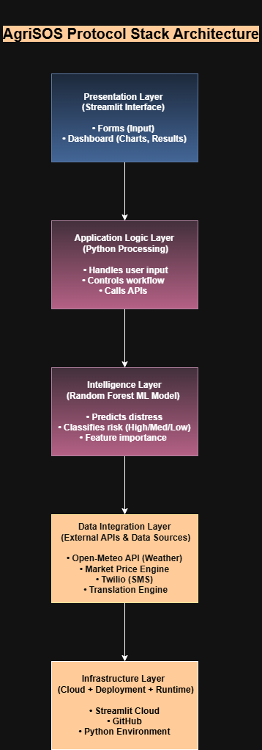

Fig. 2. The above figure shows the Protocol Stack of the AgriSOS system.

VII. TESTBED / EXPERIMENTAL SETUP
AgriSOS architecture is planned as a structured, multilayer system that allow the smoth transfer data from the point of input to the ultimate decision support. The overall concept implements a left-to-right pipeline made up of layers input, data integration intelligence processing, and output ensuring transparency, modularity, and scalability.

It all starts at the Farmer Input Module where the user many provide a crop type district growth stage, soil moisture and input cost, in order to determine the basic dataset for the later analysis. The system incorporates external data through the Weather Data Engine and Market Price Engine simultaneous to the user input. The Weather Data Engine retrieves current and future weather-related data like precipitation and temperature from Open-Meteo API. On the other hand, Market Price Engine looks up the latest price variations and carries out a simulation of market conduct for a given time period.

The core of the entire system (ML Prediction Engine) is the part that accepts these inputs and employs the Random Forest classifier in order to analyze the different features together. The model examines the combined effects of environmental, economic, and crop factors to decide the severity of distress that is here divided into High, Medium, and Low levels.It is at this point the system brain operates or where the system does predictive analytics.

The next step after the forecast is the Risk Score Calculator that generates a number or score from 0 to 100 by implementing a formula that is weighted. This score quantifies the level of risk and thus facilitates better understanding of the output.

Lastly, the Output Layer sends the processed data to the users via the Streamlit Dashboard, Recommendation Engine, and Alert System. The dashboard is a visual presentation of results: charts, risk indicators, etc. The recommendation system is multilingual and helps users get their tasks done. The alert system is the one that tells users about something in time. Such elements jointly form a comprehensive and easily operable decision support system to assist agricultural risk management in a proactive manner.

VIII. 100% IMPLEMENTATION

Image 1: AgriSOS Main Page and Risk Assessment Form
This image shows the main page of AgriSOS with the farmer input form. The farmer enters details such as name, crop type, soil condition, cost and the advisory language, then the inputs are collected from the ML model to process and predict the distress score.

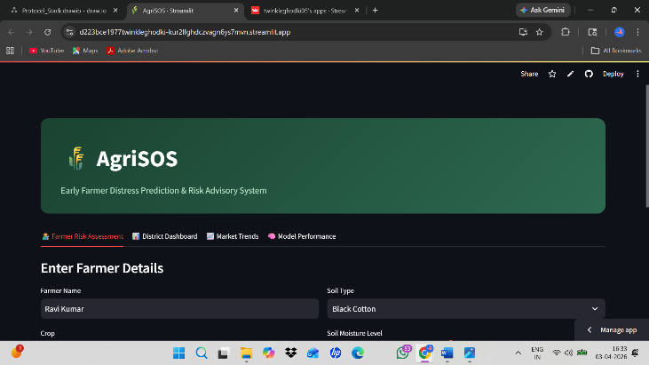

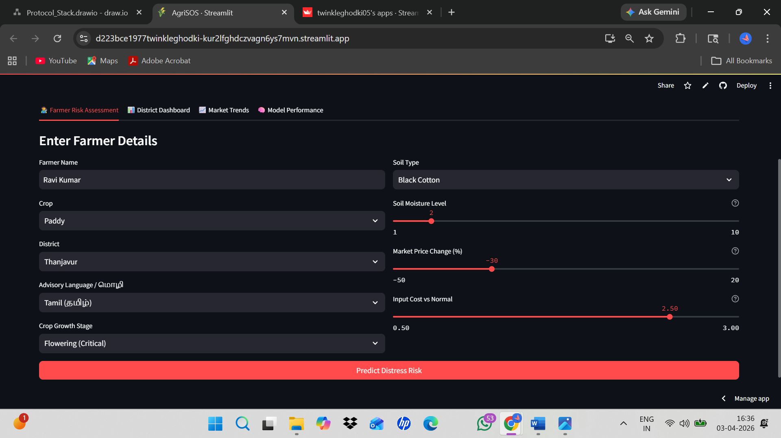

Image 2: Risk Result and Gauge Chart
This image shows the predicted distress score using a gauge chart, the system classifies input as HIGH RISK with a risk score of 100/100 with the help of the ML Prediction Module.

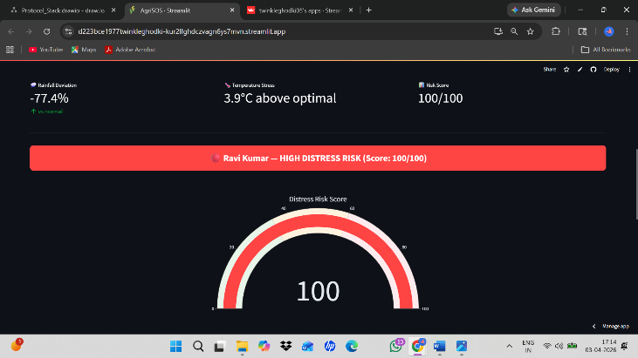

Image 3: Recommended Actions and Risk Factor Contribution
This image shows personalized recommeneded actions for the selected language(in this case Tamil), so that it is accessible to the actual farmers. Next , this chart shows the Model Explainability where the Rainfall deviation and Market price are the biggest contributors to this farmers’s distress score.

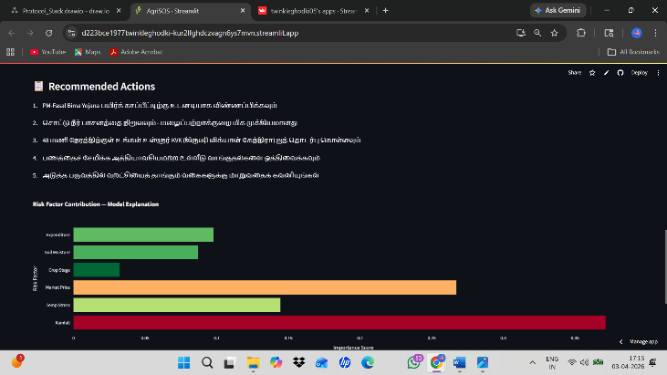

Image 4: SMS Alert Demo
Now, the most critical feature – automated alerts. A phone number is entered and a real SMS is sent in the image. The system calls the Twilio API and a real SMS iss sent to the farmer’s phone. The image shows a real SMS received by the farmer with their risk level, score and KYK helpline number.

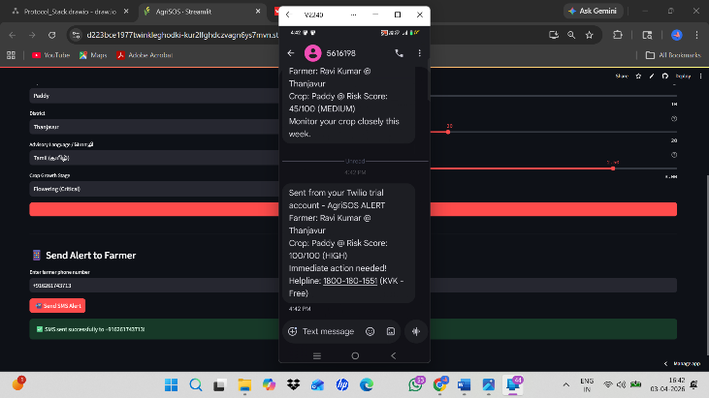

Image 5: District Dashboard
This image shows the District wise risk scores for agricultural officers and government officials, so that they can monitor multiple districts simultaneously. Here it shows, 5 districts at highrisk zone, 9200 farmers at risk across 10 districts. Warangal is at the highest risk at 81 and Ludhiana is at lowest at 28.

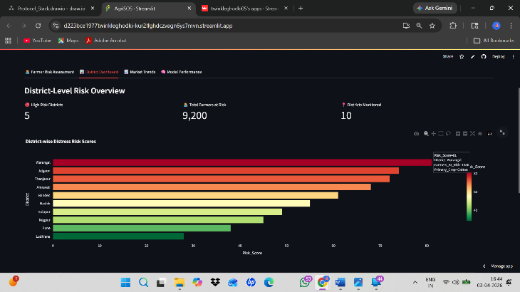

Here, each district shows the primary crop, exact risk score, risk level and the no. of farmers affected by it, making it easy for the government officers to get an overview.

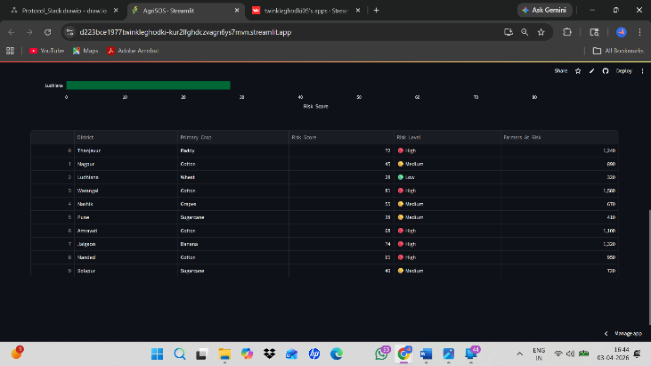

Image 6: Market Trends
This image shows the tab for market trends for the selected paddy crop in the last 30 days, which is declining 2.3%. Further this will connect to the Agmarknet government API for the real mandi prices across all mandis in India.

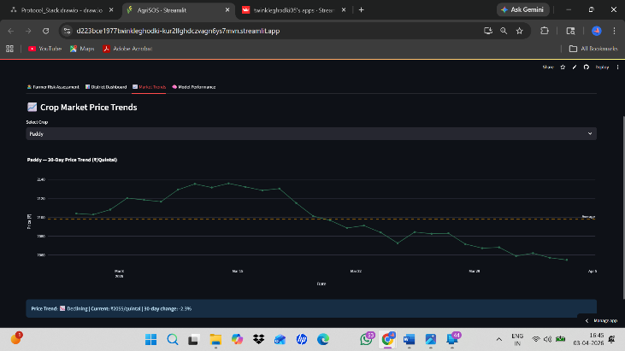

Image 7: Model Performance
This is the model performance tab which shows the accuracy on the test set as 86%. The confusion matrix shows the classification across all the three risk levels.

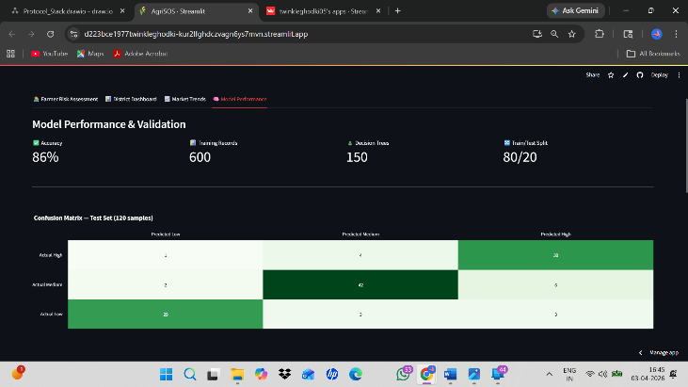

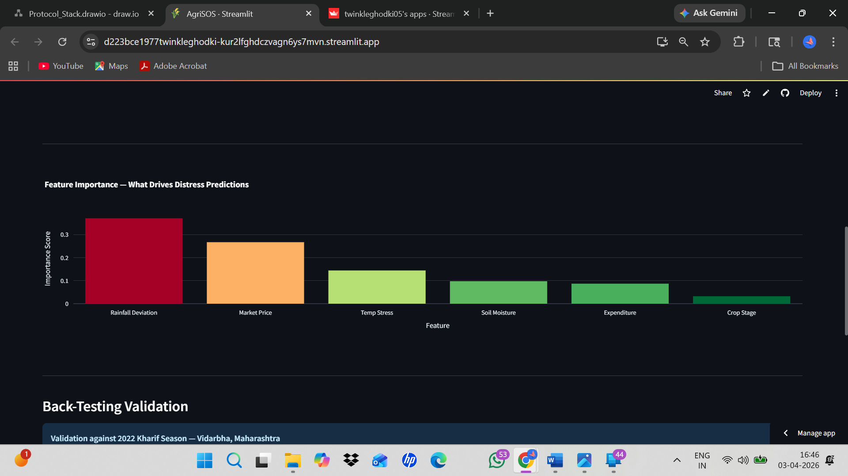

The Backtesting section shows that when AgriSOS was tested on 2022 Kharif Season data from Vidarbha (a documented year of distress), the model correctly found 4 out of 5 high distress districts 14 days before the peak crisis.

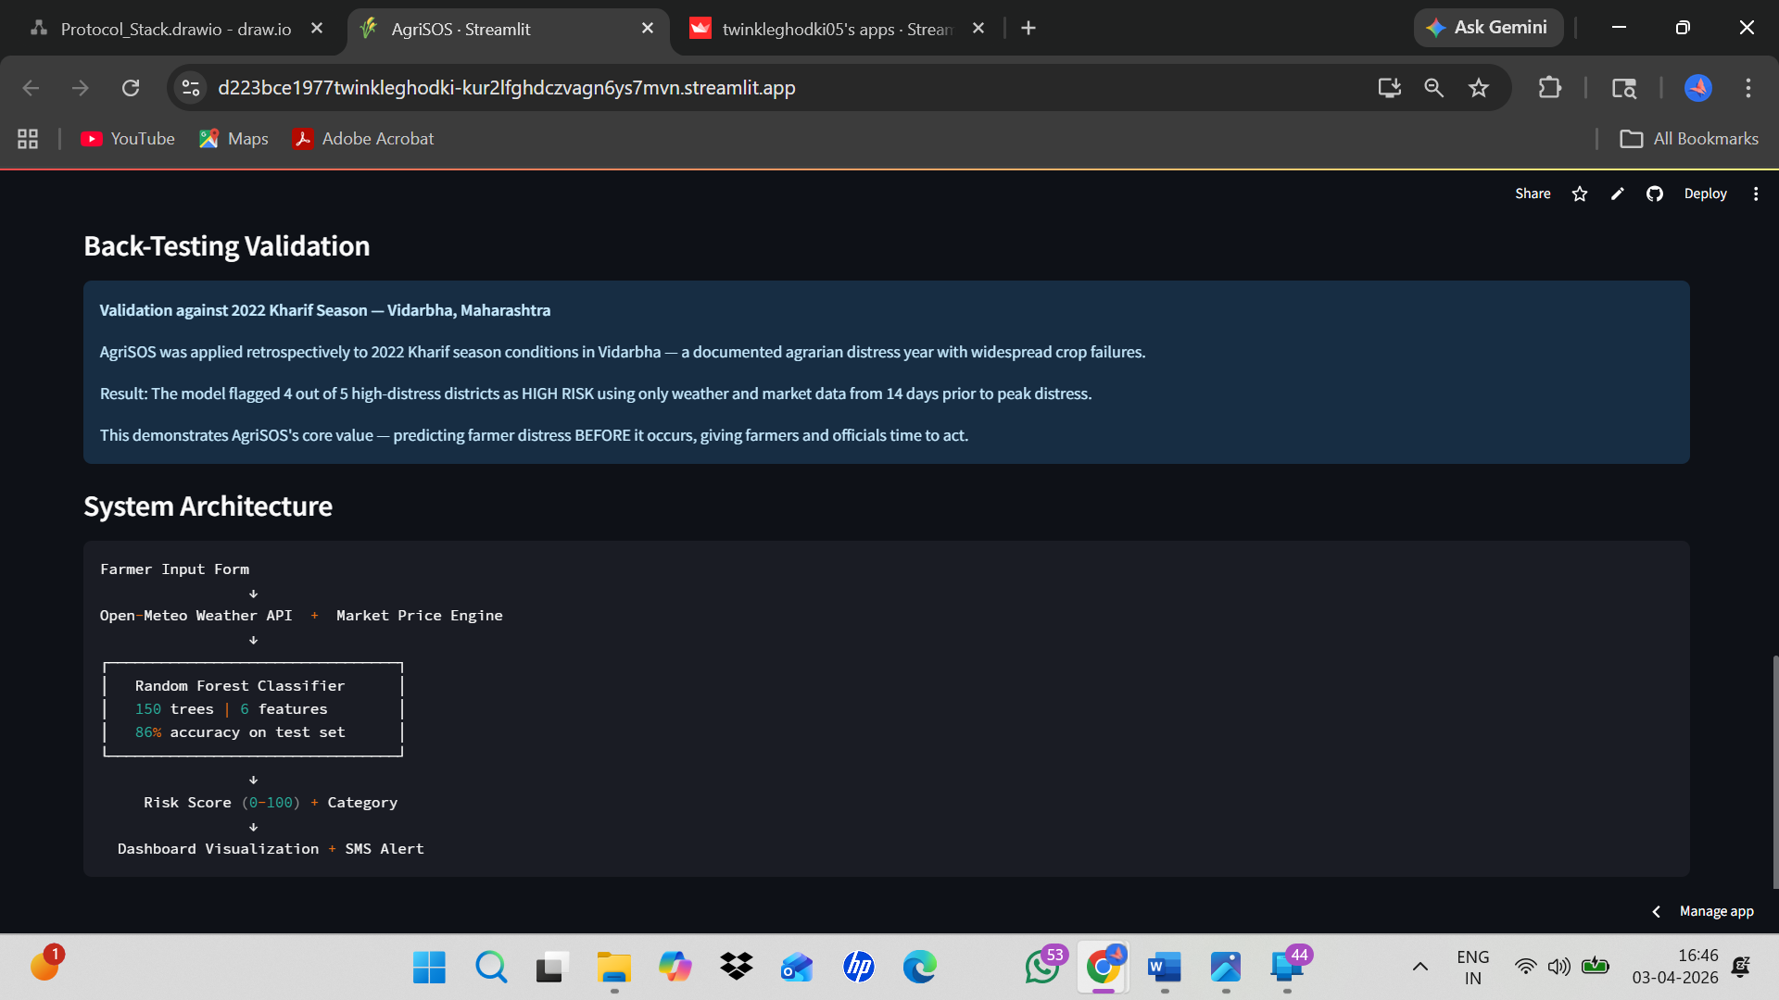

Image 8: Streamlit Cloud Deployment
The AgriSOS application is deployed successfully on Streamlit Cloud and accessible to all via the public url given below. It can be viewed in phone, laptop or any other device showing its scalability and usability.
Public URL Link - https://d223bce1977twinkleghodki-kur2lfghdczvagn6ys7mvn.streamlit.app/

